PS Lab Sheet -10

IT24103083-Jayasundara H.J.M.N.D

1)Exercise 1

1. A vending machine owner claims that customers choose the four snack types (A, B, C, D) with equal probability. To test this claim, a researcher records the number of purchases for each snack type during one week and results are given below.

|  |  |
| --- | --- |
| Snack Type | Count |
| A | 120 |
| B | 95 |
| C | 85 |
| D | 100 |

1. A screenshot of a computer

   AI-generated content may be incorrect.

1. 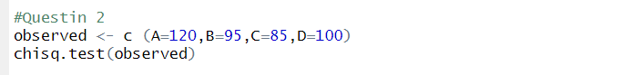

1. 